# CCTA Test 2: Flow Profile Test Report

Yousuf Araim

Aly Pirbay

Date: April 19, 2025

## Objective

The objective of this test is to characterize the flow profile within the CCTA, both in the Inferior Vena Cava (IVC) and the Right Atrium (RA), to determine whether it meets the requirements set by Boston Scientific (BSC). Table 1 presents the target fluid profiles at these locations, as specified by BSC.

Table 1: Desired Flow Profiles set by Boston Scientific.

|  |  |
| --- | --- |
| Location | Flow Profile |
| Inferior Vena Cava | Laminar |
| Common Femoral Vein | Laminar |
| Right Atrium | Turbulent |
| Left Atrium | Turbulent |

## Equipment Needed

Table 2: Test Apparatus.

|  |  |
| --- | --- |
| Item | Purpose |
| CCTA | Device to be tested |
| CCTA MATLAB App | Control the system |
| Male Luer Syringe | System debubbling |
| Power Supply (0-12 V DC) | Power the system |
| Red Food Colouring | Visualise the flow profile |
| Video Camera | Record the fluid motion |

## Theoretical Prediction

To determine whether the flow is laminar or turbulent the Reynolds number (*Re*) was calculated using the standard formula:

$$Re=\frac{ρ⋅v⋅D}{μ}$$

**Inferior Vena Cava**

Where:

$Re$ = Reynolds number (dimensionless)

$ρ$ = Density of the fluid (kg/m³)

$v$ = Mean velocity of the fluid (m/s)

$D$ = Inner diameter of the tube (m)

$μ$ = Dynamic viscosity of the fluid (Pa·s)

System Parameters:

Flow rate ($Q$) = 1.02 L/min = $\frac{1.02}{1000×60}=1.70×{10}^{-5} {\text{m}}^{3}/\text{s}$*(Specified by BSC)*

Inner diameter of tubing ($D$) = 3/8" = 0.375 in × 0.0254 m/in = 0.009525 m

Density of water ($ρ$) ≈ 997 kg/m³ (at 25°C) [1]

Dynamic viscosity of water ($μ$) ≈ 0.00089 Pa·s (at 25°C) [2]

Cross-Sectional Area

$$A=\frac{πD^{2}}{4}=\frac{π{\left(0.009525\right)}^{2}}{4}=7.13×{10}^{-5} {\text{m}}^{2}$$

Average Flow Velocity

$$v=\frac{Q}{A}=\frac{1.70×{10}^{-5}}{7.13×{10}^{-5}}=0.2384 \text{m/s}$$

Reynolds Number

$$Re=\frac{ρ⋅v⋅D}{μ}=\frac{997⋅0.2387⋅0.009525}{0.00089}=2540$$

**Right Atrium**

$$Re=\frac{ρ⋅v⋅D}{μ}$$

Where:

$D$ = 35 mm = 0.035 m

$Q$ = 3.89 L/min **= $6.483×{10}^{-5} {\text{m}}^{3}/\text{s}$**  (*Measured from the system when the IVC flow rate is 1.02 L/min*)

$$A=\frac{πD^{2}}{4}=\frac{π{\left(0.035\right)}^{2}}{4}=9.6211×{10}^{-4} {\text{m}}^{2}$$

$$v=\frac{Q}{A}=\frac{6.483×{10}^{-5}}{9.6211×{10}^{-4}}=0.06735 \text{m/s}$$

$$Re=\frac{997⋅0.06735⋅0.035}{0.00089}=\frac{2.343}{0.00089}=2633$$

The calculated Reynolds number for flow within the 3/8″ flexible tubing (representing the IVC) was **Re = 2540**, while the Reynolds number for flow in the heart chamber (flow rate = 3.89 L/min, diameter = 35 mm) was **Re = 2631**. Both values lie squarely within the transitional regime (**2300 < Re < 4000**) [3], indicating that the flow is neither fully laminar nor fully turbulent. In this intermediate state, small variations in velocity, fluid properties, or geometry can push the flow toward either laminar or turbulent behavior. To visualize and better understand these mixed profiles, a dye-tracing experiment was conducted; its setup and findings are described in the next section.

## Dye-Tracing Experiment

### Test Procedure

**1. Set Up the System**

* Set the CCTA up using the following schematic as a reference:

Figure 1: CCTA Test 1 setup schematic.

* Connect the power supply to the control box using the designated banana plugs.
* Connect the control box to your laptop using the USB cable.

**2. Open the needle valve to the Silver line (fully Open)**

**3. Fill the system with water until the water level is just underneath the top barb in the reservoir**

**4. Run and debubble the system for 5 minutes.**

* Turn on the power supply and set it to **12 V**.
* Open the CCTA MATLAB App and click “Connect”.
* Set the Control Mode to manual.
* Set the Pump Power (duty cycle) to **50%**.
* Visually inspect the system for any bubbles, use the Luer syringe to debubble the pressure sensors. Squeeze the tubing where there are large bubbles to push the bubbles out.
* Add water to the reservoir if needed.

**6. Adjust the pump power, needle valve throttle and the pressure regulator valve throttle to achieve a flow rate of 1.02 L/min in the IVC.**

**7. Remove Pressure Sensor 2 (highlighted with a blue border in Figure 1) and replace is with Male Luer Syring filled with red dye as shown in Figure 2.**

Figure : Male Luer syringe filled with dye and connected to the luer fitting instead of pressure sensor 2.

**8. Use a video camera to capture the fluid flow in slow motion as you inject the dye into the tube.**

### Test Results and Discussion

You can find the slow-motion video under the “Flow Profile Test” folder in the “CCTA Verification Tests”.

As shown in Figure 3, the fluid appears laminar in the initial section of the inferior vena cava (IVC) while inside the plastic fitting (Red Box). However, it becomes turbulent at the boundary where the plastic fitting transitions to the flexible tubing (Yellow Box). This observation aligns with the theoretical flow predictions discussed earlier. The exact cause of the turbulence at this boundary is uncertain, but it is speculated that the sharp edge at the end of the barb fitting generates eddies. It is also hypothesized that as the fluid continues downstream, the flow redevelops and may return to a laminar regime, as suggested by the smooth flow profile observed when the fluid exits the loop into the bucket. Further testing is required to confirm whether the flow remains laminar throughout the entire length of the IVC.

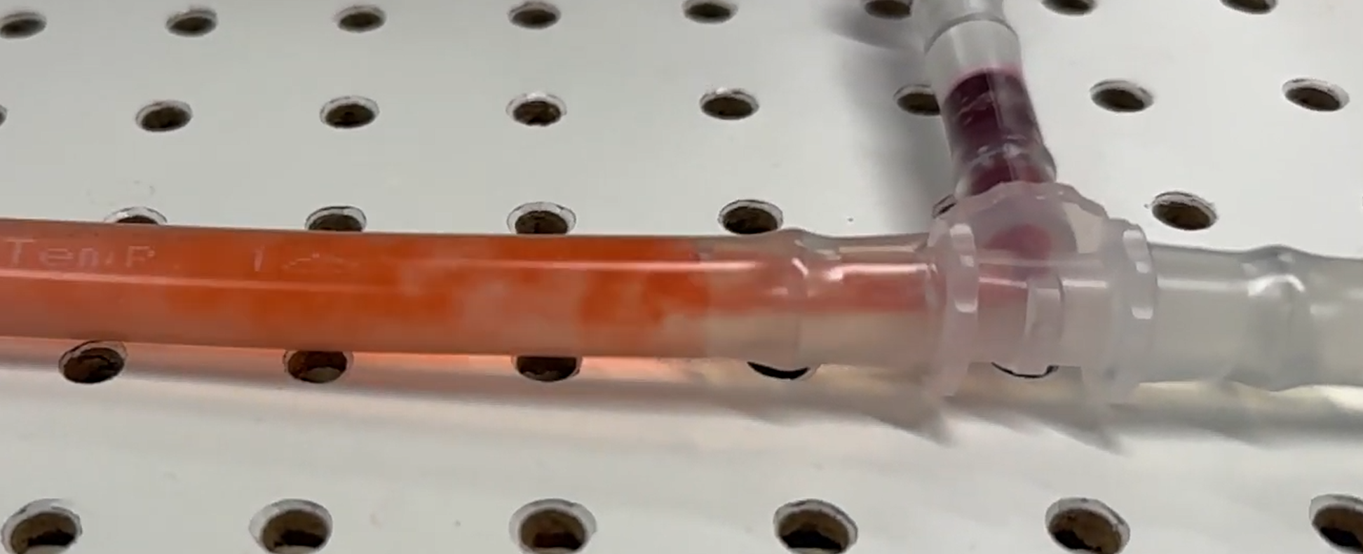

Figure : IVC Flow Profile (Laminar in the T-Fitting and Turbulent at the Junction).

In contrast, the flow within the right atrium (RA) appears turbulent, as seen in Figure 4. Although theoretical calculations indicate transitional flow, the heart’s geometry specifically the direct alignment of the IVC and superior vena cava (SVC) induces turbulence, despite the relatively low Reynolds number.

Figure : Qualitative inspection of turbulent flow in the right atrium.

## ANSYS Simulation

In addition to the physical tests, Computational Fluid Dynamics (CFD) simulations were carried out using Ansys Fluent to further validate these observations. By importing the measured flow rate and outlet pressure, detailed CAD geometry of the heart model, and standard water properties into the software, velocity distributions and streamline plots were generated (Figure X). The simulation results vividly captured high velocity gradients and eddy formations inside the heart region, aligning with the experimental evidence of turbulent flow.

Figure 5: Streamline analysis of fluid in the right atrium.

## Conclusion

Overall, the test was successful in characterizing the flow behavior within the CCTA. Results indicate that the flow within the right atrium (RA) is clearly turbulent, as expected due to the complex geometry and the direct inflow from both the inferior vena cava (IVC) and superior vena cava (SVC). In contrast, the flow in the IVC did not exhibit characteristics that are definitively turbulent or laminar. Instead, it appeared transitional, with initial laminar behavior near the plastic fitting and the onset of turbulence at the junction with the flexible tubing.

To achieve fully developed laminar flow in the IVC, a fluid with higher dynamic viscosity should be considered. Glycerol-water mixtures, commonly used in cardiovascular flow modeling, provide an effective solution due to their significantly higher viscosity compared to water or saline. For instance, a 60% glycerol solution yields a dynamic viscosity of approximately 0.013 Pa·s at 25 $℃$ [4]. Using this fluid in 3/8” tubing at a flow rate of 1.02 L/min would result in a Reynolds number of approximately 178, which is well below the critical threshold (Re < 2000), confirming laminar flow conditions.

Using a fluid with higher viscosity not only enables better control of the flow regime but also enhances the physiological relevance of the test setup, especially when modeling venous return where laminar flow is typically expected. Future testing should incorporate glycerol-based fluids to ensure consistent and predictable flow profiles within the IVC and throughout the loop.

## References

[1] “Water Density, Specific Weight and Thermal Expansion Coefficients - Temperature and Pressure Dependence.” Accessed: Apr. 22, 2025. [Online]. Available: https://www.engineeringtoolbox.com/water-density-specific-weight-d_595.html

[2] “Water - Dynamic and Kinematic Viscosity at Various Temperatures and Pressures.” Accessed: Apr. 22, 2025. [Online]. Available: https://www.engineeringtoolbox.com/water-dynamic-kinematic-viscosity-d_596.html

[3] A. Rónaföldi, A. Roósz, and Z. Veres, “Determination of the conditions of laminar/turbulent flow transition using pressure compensation method in the case of Ga75In25 alloy stirred by RMF,” *J. Cryst. Growth*, vol. 564, p. 126078, Jun. 2021, doi: 10.1016/j.jcrysgro.2021.126078.

[4] “Calculate density and viscosity of glycerol/water mixtures.” Accessed: Apr. 22, 2025. [Online]. Available: https://www.met.reading.ac.uk/~sws04cdw/viscosity_calc.html